(Luo 2020)

Luo Zhenjin [罗振津]. 2020. “Research on Rescue and Protection of Rare Resources in Library——Taking the Rescue and Protection of Chinese Newspapers Collected in Tianjin Library Before the Founding of the People’s Republic of China as an Example” [图书馆馆藏珍稀资源抢救与保护研究——以天津图书馆馆藏建国前中文报纸抢救与保护为例]. Library Work and Study [图书馆工作与研究], no. 10: 89–93. https://doi.org/10.16384/j.cnki.lwas.2020.10.013.

Collection of rare newspapers from Tianjin

"Tianjin Daily"《天津日报》, "People's Daily"《人民日报》, "Wen Wei Po" 《文汇报》and "Ta Kung Pao"《大公报》before the founding of the People’s Republic of China (1949.01-1949.09) in the collections of the Tianjin Library

realized the digitization of rare newspaper resources through microfilming.

Historic background on the collections, founder, calligrapher, etc

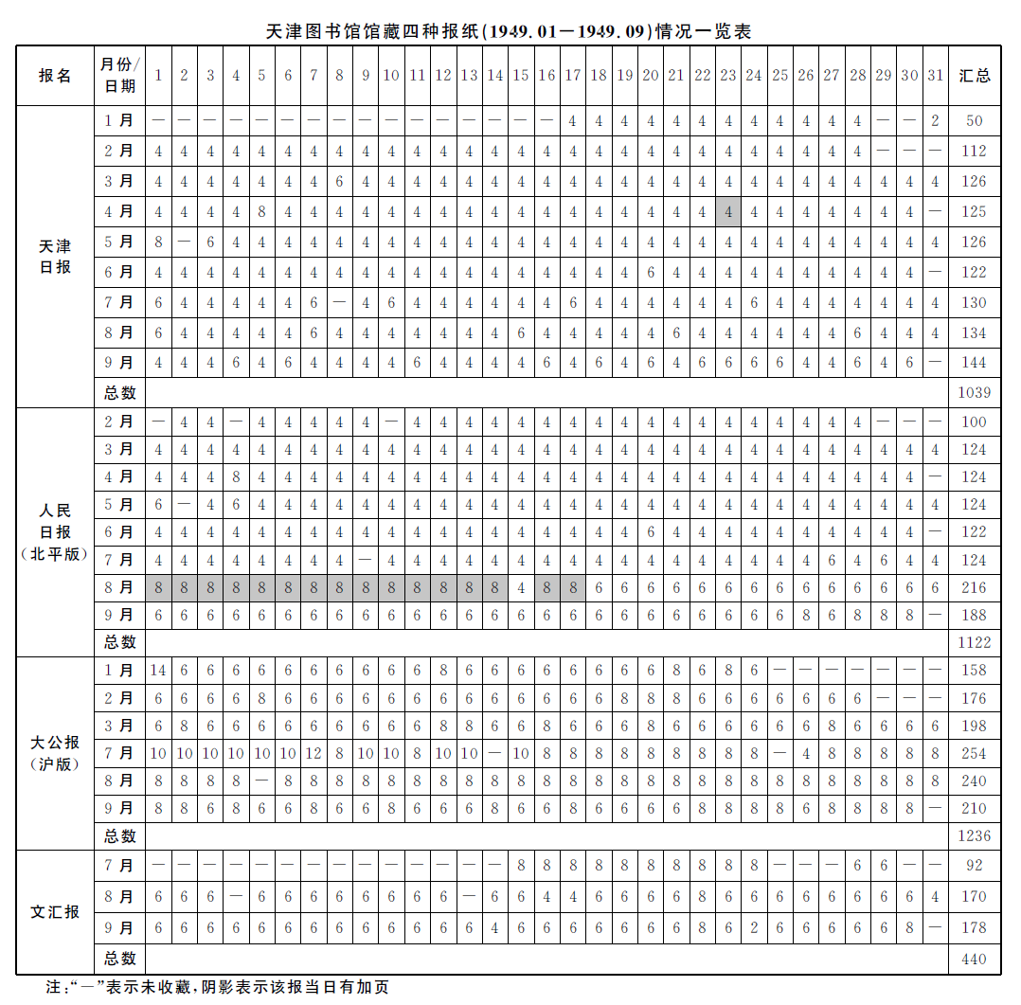

4　 Thoughts on the protection and management of Chinese newspapers in libraries

　　 The microfilming work of the four newspapers is just the beginning of the protection of Chinese newspapers.

Many newspapers have been aging to varying degrees. Even if readers read them carefully, the damaged paper will drop. Therefore, the effective protection and management of newspapers should be put on the agenda, and the deeper protection of newspapers should not be emphasized after the aging of the newspapers. At ordinary times, attention should be paid to temperature, humidity, and insect control, and try to do it under existing conditions. Constant temperature and humidity to the storage space.

The author believes that the overall protection plan for the collection of newspapers should be formulated as soon as possible, the existing funds should be used rationally, and multiple measures should be taken:

first, determine the collection level of the collection of newspapers, and use the newspapers that are determined to be permanently preserved as the basic collection; for those that are determined to be preserved regularly The newspaper sets a shelf life.

Secondly, it is necessary to treat the newspapers published in secondary processing differently, and comprehensively consider the publication level, circulation ranking, popularity of readers and other factors to determine the collection level.

Third, do a good job of anti-acid treatment of newspapers, pay attention to relevant work trends at home and abroad, and adopt advanced technical means to protect the collection of documents.

In other words, the library should take protective measures immediately after the newspaper is published, rather than rescue it after the newspaper is aging and the paper is fragile. For the problem of newspaper aging that has already appeared, it is necessary to formulate long-term rescue and repair plans and emergency rescue plans, and effectively implement rescue work.

Finally, establish a corresponding database for the identified key newspapers, and provide readers with multiple retrieval methods. For example, the **Tianjin Library provided an electronic version of the "Tianjin Daily" in 2012. The time span is from October 1939 to December 2013**. In the daily reader service process, the electronic version of the "Tianjin Daily" has a higher usage rate. Popular among young readers, it works with paper newspapers to serve readers with good results.

The construction of newspaper databases is very important, especially for newspapers with a relatively long history, which are closer to history and are the main carrier of social culture at that time, with great social cultural value and historical material value. For this reason, in the construction of newspaper database in the future, the development and utilization of old newspapers in the collection should not only stop at providing the full text of documents, but should combine the **characteristics of each newspaper** to provide readers with **multiple retrieval methods, title, author, and time. , Columns, editions, full text**, and even **information in the middle of a newspaper must provide access** points. In 2013, the "Tianjin Daily" database could not provide the information in the folds of newspapers, but in the reader service work, it was found that there was a large amount of inquiries about slits in newspapers. Missing notices, announcement statements, etc. were all published here, while paper newspapers were bound together. After that, **the content of the middle seam in the newspaper cannot be accessed**. For this reason, the author suggests to archive the contents of the middle seam of the newspaper when taking photos of the "Tianjin Daily".

In addition, while providing indexing and searching channels from multiple angles to increase the breadth of newspaper resources, it is also necessary to **strengthen the promotion and promotion of newspaper databases, optimize search channels**, so that more readers can learn to use newspaper databases, and the value of old newspapers in the collection can be realized. fully use.